Predicting Labour Wages using Ridge and Lasso Regression

Arnav Roy

Table of Contents

Ridge and Lasso Regression 1

R Markdown 1

Read and Understand the data 2

Data Pre-processing 3

Train-Test Split 3

Standardize the Data 3

Dummify the Data 3

Get the data into a compatible format 3

Hyper-parameter Tuning 4

Choosing a lambda for Lasso Regression 4

Choosing a lambda for Ridge Regression 5

Building The Final Model 7

Building the Final Lasso Regression Model 7

Building the Final Ridge Regression Model 7

Model Performance Evaluation 8

Lasso Regression Model Metrics 8

Ridge Regression Model Metrics 8

# Ridge and Lasso Regression

$$RSS(β)+λ\sum_{j=1}^{p}{β_{j}^{2}}$$

$$RSS(β)+λ\sum_{j=1}^{p}{|}β_{j}|$$

## R Markdown

#Reading libraries

library(caret)

## Warning: package 'caret' was built under R version 3.6.3

## Loading required package: lattice

## Loading required package: ggplot2

library(glmnet)

## Warning: package 'glmnet' was built under R version 3.6.3

## Loading required package: Matrix

## Loaded glmnet 4.0-2

library(DMwR)

## Warning: package 'DMwR' was built under R version 3.6.3

## Loading required package: grid

## Registered S3 method overwritten by 'quantmod':  
## method from  
## as.zoo.data.frame zoo

#Removing env variables

rm(list=ls(all=TRUE))

#Setting working directory

getwd()

## [1] "C:/Users/Arnav/Desktop/Semester 3/ML/R"

setwd("C:/Users/Arnav/Desktop/Semester 3/ML/R")

# Read and Understand the data

labour_data=read.csv(file='labour_income.csv',header=T)  
summary(labour_data)

## wages education age sex language   
## Min. : 2.30 Min. : 0.00 Min. :16.0 Female:2001 English:3244   
## 1st Qu.: 9.25 1st Qu.:12.00 1st Qu.:28.0 Male :1986 French : 259   
## Median :14.13 Median :13.00 Median :36.0 Other : 484   
## Mean :15.54 Mean :13.34 Mean :37.1   
## 3rd Qu.:19.72 3rd Qu.:15.10 3rd Qu.:46.0   
## Max. :49.92 Max. :20.00 Max. :69.0

str(labour_data)

## 'data.frame': 3987 obs. of 5 variables:  
## $ wages : num 10.6 11 17.8 14 8.2 ...  
## $ education: num 15 13.2 14 16 15 13.5 12 14 18 11 ...  
## $ age : int 40 19 46 50 31 30 61 46 43 17 ...  
## $ sex : Factor w/ 2 levels "Female","Male": 2 2 2 1 2 1 1 1 2 2 ...  
## $ language : Factor w/ 3 levels "English","French",..: 1 1 3 1 1 1 1 3 1 1 ...

# Data Pre-processing

## Train-Test Split

* Split the data into train and test

set.seed(007)  
train_rows <- sample(x=seq(1,nrow(labour_data),1),size=0.7*nrow(labour_data))  
train_data <- labour_data[train_rows,]  
test_data <- labour_data[-train_rows,]

## Standardize the Data

* Standardize the continuous independent variables

std_obj <- preProcess(x = train_data[, !colnames(train_data) %in% c("wages")],method = c("center", "scale"))  
  
  
train_std_data <- predict(std_obj,train_data)  
  
test_std_data <- predict(std_obj,test_data)

## Dummify the Data

* Use the dummyVars() function from caret to convert sex and age into dummy variables

dummy_obj <- dummyVars(~.,train_std_data)  
  
train_dummy_data <- as.data.frame(predict(dummy_obj,train_std_data))  
  
test_dummy_data <- as.data.frame(predict(dummy_obj,test_std_data))

## Get the data into a compatible format

* The functions we will be using today from the glmnet package expect a matrix as an input and not our familiar formula structure, so we need to convert our dataframes into a matrix

X_train <- as.matrix(train_dummy_data[,-1])  
y_train <- as.matrix(train_dummy_data[,1])  
X_test <- as.matrix(test_dummy_data[,-1])  
y_test <- as.matrix(test_dummy_data[,1])

# Hyper-parameter Tuning

* Choose an optimal lambda value for the ridge and lasso regression models by using cross validation

## Choosing a lambda for Lasso Regression

* The alpha value is 1 for lasso regression

cv_lasso <- cv.glmnet(X_train,y_train,alpha=1,type.measure ="mse",nfolds=4 )  
  
plot(cv_lasso)

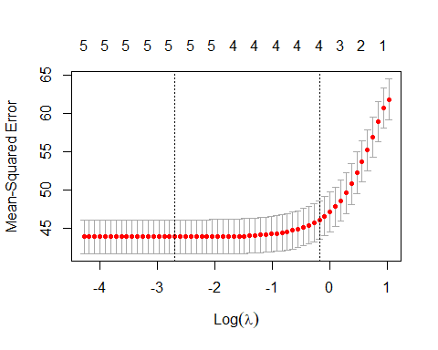

* The object returned form the call to cv.glmnet() function, contains the lambda values of importance
* The coefficients are accessible calling the coef() function on the cv_lasso object

plot(cv_lasso$glmnet.fit,xvar="lambda",label=TRUE)

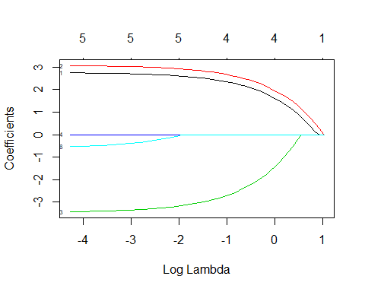

print(cv_lasso$lambda.min)

## [1] 0.06803175

coef(cv_lasso)

## 8 x 1 sparse Matrix of class "dgCMatrix"  
## 1  
## (Intercept) 1.640412e+01  
## education 1.812587e+00  
## age 2.153717e+00  
## sex.Female -1.766271e+00  
## sex.Male 8.259089e-14  
## language.English .   
## language.French .   
## language.Other .

## Choosing a lambda for Ridge Regression

* The alpha value is 0 for ridge regression

cv_ridge <- cv.glmnet(X_train,y_train,alpha=0,type.measure ="mse",nfolds=4 )  
  
plot(cv_ridge)

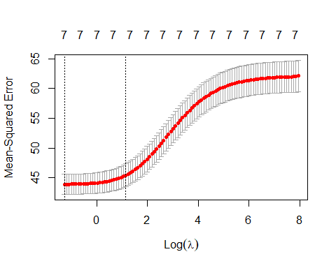

* We can access the lambda and the coefficients as we did before

plot(cv_ridge$glmnet.fit,xvar="lambda",label=TRUE)

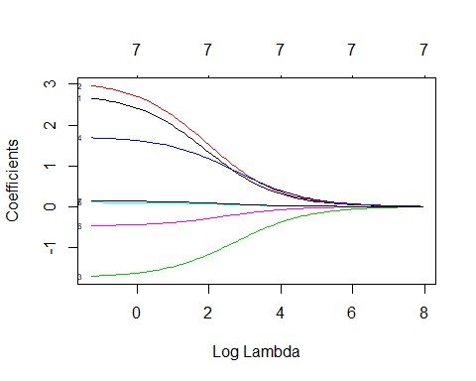

print(cv_ridge$lambda.min)

## [1] 0.281108

coef(cv_ridge)

## 8 x 1 sparse Matrix of class "dgCMatrix"  
## 1  
## (Intercept) 15.46625297  
## education 1.89683861  
## age 2.13566648  
## sex.Female -1.44034175  
## sex.Male 1.43636353  
## language.English 0.08263341  
## language.French -0.38150197  
## language.Other 0.11172119

# Building The Final Model

* By using the optimal lambda values obtained above, we can build our ridge and lasso models

## Building the Final Lasso Regression Model

lasso_model <- glmnet(X_train,y_train,lambda=cv_lasso$lambda.min,alpha=1)  
  
coef(lasso_model)

## 8 x 1 sparse Matrix of class "dgCMatrix"  
## s0  
## (Intercept) 1.719687e+01  
## education 2.689314e+00  
## age 3.006946e+00  
## sex.Female -3.314947e+00  
## sex.Male 2.811204e-13  
## language.English .   
## language.French -3.176708e-01  
## language.Other .

* Use the model to predict on test data

pred_lasso <- predict(lasso_model,X_test)

## Building the Final Ridge Regression Model

ridge_model <- glmnet(X_train,y_train,lambda=cv_ridge$lambda.min,alpha=0)  
  
coef(ridge_model)

## 8 x 1 sparse Matrix of class "dgCMatrix"  
## s0  
## (Intercept) 15.5071089  
## education 2.6575550  
## age 2.9648092  
## sex.Female -1.7573840  
## sex.Male 1.6383518  
## language.English 0.1050676  
## language.French -0.4659695  
## language.Other 0.1378338

* Use the model to predict on test data

pred_ridge <- predict(ridge_model,X_test)

# Model Performance Evaluation

## Lasso Regression Model Metrics

regr.eval(trues=y_test,preds=pred_lasso)

## mae mse rmse mape   
## 4.920026 43.191036 6.571989 0.380545

## Ridge Regression Model Metrics

regr.eval(trues=y_test,preds=pred_ridge)

## mae mse rmse mape   
## 4.9280828 43.2711221 6.5780789 0.3814506